

DEPARTMENT OF COMPUTER SCIENCE AND ENGINEERING III B E – COMPUTER SCIENCE AND ENGINEERING












DEPARTMENT OF COMPUTER SCIENCE AND ENGINEERING

Certified Bonafide record of work done by Mr./Ms. -------------------------------------------------------

Reg,No. during the ODD Semester of Academic Year 2025-2026.

Staff-In Charge HOD

Submitted for the end semester practical examination held on -----------------------------

Internal Examiner External Examiner

1 |  | A simple AI-based Python script
2 |  | Exploring AI applications in real-world case studies.
3 |  | Implementing BFS and DFS in Python.
4 |  | A* and Greedy Best-First Search to find the shortest path in a grid.
5 |  | Tic-Tac-Toe using the Minimax algorithm.
6 |  | A basic propositional logic reasoning system.
7 |  | A simple knowledge base using First-Order Logic.
8 |  | A semantic network to represent relationships between objects.
9 |  | A basic expert system for medical diagnosis
10 |  | Performing tokenization, stemming, and stop-word  removal on sample text.
11 |  | A speech-to-text system using Python’s speech recognition  library
12 |  | Implementing AI for a real-world problem (e.g., predicting student performance).


DEPARTMENT OF INFORMATION TECHNOLOGY

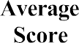

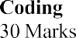
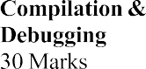
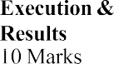
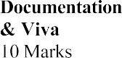

Exp. No.: 1 Date:

Implement a simple AI -based Python script Sentiment Analysis using TextBlob

Aim:
To implement a simple AI-based sentiment analysis program using the TextBlob
library in Python to classify a sentence or paragraph as Positive, Negative, or Neutral based on its polarity.

Algorithm:
- 1 Start the program.
- Import the required library: TextBlob.
- Accept user input (a sentence or paragraph).
- Create a TextBlob object using the input text.
- Use the .sentiment.polarity property to compute the sentiment score.
- Determine the sentiment:
  - If polarity > 0 → Positive
  - If polarity < 0 → Negative
  - If polarity = 0 → Neutral
- Display the sentiment and polarity score.
- End the program.
  - If polarity > 0 → Positive
  - If polarity < 0 → Negative
  - If polarity = 0 → Neutral
- Display the sentiment and polarity score.
- End the program

Program:
# Importing the required library from textblob import TextBlob # Welcome message
print("Welcome to the AI Sentiment Analysis Lab!")
print("This program analyzes the sentiment of your text (positive, neutral, or negative).") # Input from the user
user_input = input("\nEnter a sentence or paragraph to analyze: ") # Create a TextBlob object
analysis = TextBlob(user_input) # Analyze sentiment polarity
# Polarity ranges from -1 (negative) to 1 (positive) polarity = analysis.sentiment.polarity
# Determine sentiment category if polarity > 0:
sentiment = "Positive" elif polarity < 0:
sentiment = "Negative" else:
sentiment = "Neutral" # Display the result
print("\nSentiment Analysis Result:") print(f"Polarity Score: {polarity}") print(f"Sentiment: {sentiment}")
# Goodbye message
print("\nThank you for using the AI Sentiment Analysis Lab!")

Output:
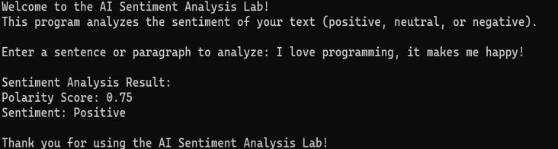

Result:
Thus the above program was implemented and successfully completed.

Exp. No.: 2 Date:
Exploring AI Applications in Real-World Case Studies

Aim:
To explore the role of Artificial Intelligence (specifically ChatGPT) in supporting
students during real-world physics experiments, focusing on its effectiveness in problem- solving, data interpretation, and conceptual understanding under teacher supervision.

Algorithm:
- Start
- Form student teams (7 groups).
- Setup the acoustic levitation apparatus for measuring the speed of sound.
- Integrate AI (ChatGPT) to assist students with:
  - Formula guidance
  - Step-by-step procedures
  - Error correction
  - Data analysis
- Teachers monitor AI-student interaction, noting accuracy and effectiveness.
- Conduct a reflection session: students fill surveys and discuss AI’s role.
- End

Program:
from textblob import TextBlob def analyze_feedback(text):
blob = TextBlob(text)
polarity = blob.sentiment.polarity if polarity > 0:
return "Positive feedback on AI assistance" elif polarity < 0:

return "Negative feedback on AI assistance" else:
return "Neutral feedback on AI assistance"
feedback = input("Enter your experience with AI in the experiment: \n") print(analyze_feedback(feedback))

Output:

Result:
Thus the above program was implemented and successfully completed.

Exp. No.: 3 Date:

Implementing BFS and DFS in Python

Aim:
To implement and demonstrate Breadth-First Search (BFS) and Depth-First Search
(DFS) algorithms in Python for solving AI search problems using graph traversal.

Procedure:
- Define a graph as a dictionary (adjacency list).
- Implement bfs (start, goal) using a queue.
- Implement dfs (start, goal) using a stack.
- Provide a start node and a goal node.
- Call both functions and observe the path to the goal node.
- Display the visiting order and final path.

Algorithm:

Breadth-First Search (BFS):
  - Start the program.
  - Create a queue and add the start node as a path (in a list).
  - Initialize an empty set to store visited nodes.
  - Repeat until the queue is empty:
    - Remove the first path from the queue.
    - Get the last node from the path.
    - If the node is the goal, display the path and exit.
    - If the node is not visited:
      - Mark it as visited.
      - For each neighbor of the node:
- Create a new path with the neighbor.

- Add the new path to the queue.
  - End the program.

Depth-First Search (DFS):
  - Start the program.
  - Create a stack and add the start node as a path (in a list).
  - Initialize an empty set to store visited nodes.
  - Repeat until the stack is empty:
    - Pop the top path from the stack.
    - Get the last node from the path.
    - If the node is the goal, display the path and exit.
    - If the node is not visited:
- Mark it as visited.
- For each neighbor of the node (in reverse order):
- Create a new path with the neighbor.
- Add the new path to the stack.
  - End the program.

Program:
from collections import deque graph = {
'S': ['A', 'B'],
'A': ['C', 'D'],
'B': ['E'],
'C': [],
'D': ['G'],
'E': ['G'], 'G': []
}
def bfs(start, goal): visited = set()

queue = deque([[start]]) print("BFS Path:") while queue:
path = queue.popleft() node = path[-1]
if node not in visited: print("Visiting:", node) visited.add(node)
if node == goal:
print("Goal found! Path:", ' -> '.join(path)) return
for neighbor in graph[node]: new_path = list(path) new_path.append(neighbor) queue.append(new_path)
print("Goal not found in BFS.") def dfs(start, goal):
visited = set() stack = [[start]]
print("\nDFS Path:") while stack:
path = stack.pop() node = path[-1]
if node not in visited: print("Visiting:", node) visited.add(node)
if node == goal:
print("Goal found! Path:", ' -> '.join(path)) return
for neighbor in reversed(graph[node]):

new_path = list(path) new_path.append(neighbor) stack.append(new_path)
print("Goal not found in DFS.") start_node = 'S'
goal_node = 'G'
print("AI Graph Search using BFS and DFS") bfs(start_node, goal_node)
dfs(start_node, goal_node)

Output:
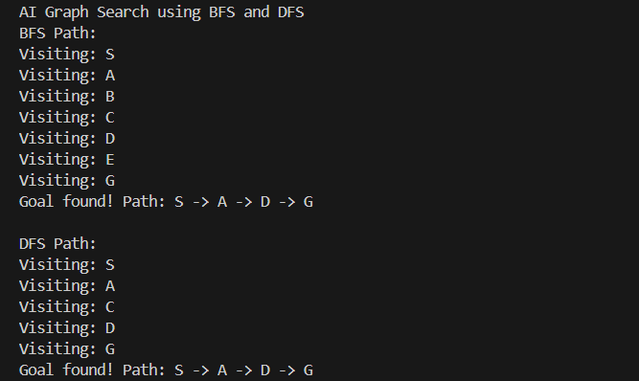

Result:
Thus the above program was implemented and successfully completed.

Exp. No.: 4 Date:
Implementing A* and Greedy Best-First Search in Python

Aim:
To implement and demonstrate A* and Greedy Best-First Search algorithms in Python
to find the shortest path in a grid using heuristic search.

Algorithm:

A* Search:
  - Start the program.
  - Create a priority queue and add the start node with cost f(n) = g(n) + h(n).
  - Initialize g(start) = 0 and an empty set for visited nodes.
  - Repeat until the queue is empty:
    - Remove the node with the lowest f(n).
    - If it is the goal node, display the path and exit.
    - If not visited:

      - Mark as visited.
      - For each neighbor:
        - Calculate g(neighbor) = g(current) + 1.
        - Calculate f(neighbor) = g(neighbor) + h(neighbor).
        - Add neighbor to the queue.
  - End the program

Greedy Best-First Search:
  - Start the program.
  - Create a priority queue and add the start node with cost f(n) = h(n).
  - Initialize an empty set for visited nodes.
  - Repeat until the queue is empty:
    - Remove the node with the lowest h(n).

    - If it is the goal node, display the path and exit.
    - If not visited:

      - Mark as visited.
      - For each neighbor:
        - Add neighbor to the queue with priority h(neighbor).
  - End the program.

Program:
import heapq
# Define the graph (adjacency list) graph = {
'A': ['B', 'D'],
'B': ['E', 'G'],
'D': ['G', 'H'],
'G': ['I'],
'H': ['I'],
'E': [],
'I': []
}
# Define heuristic values (h(n)) heuristic = {
'A': 999,
'B': 5,
'D': 2,
'E': 4,
'G': 6,
'H': 1,
'I': 0
}
# Uniform edge cost for A*

edge_cost = 1
# --- Greedy Best-First Search --- def greedy_bfs(start, goal):
print("--- Greedy Best-First Search ---") visited = set()
pq = [(heuristic[start], start)] path = []
while pq:
_, current = heapq.heappop(pq) if current in visited:
continue print("Visiting:", current) visited.add(current) path.append(current)
if current == goal: print("Path found:", path) return
for neighbor in graph[current]: if neighbor not in visited:
heapq.heappush(pq, (heuristic[neighbor], neighbor)) print("Goal not found using Greedy BFS.")
# --- A* Search --- def a_star(start, goal):
print("\n--- A* Search ---") visited = set()
pq = [(heuristic[start], 0, start, [])] # (f(n), g(n), node, path) while pq:
f, g, current, path = heapq.heappop(pq) if current in visited:
continue

print("Visiting:", current) visited.add(current)
path = path + [current] if current == goal:
print("Path found:", path) return
for neighbor in graph[current]: if neighbor not in visited:
new_g = g + edge_cost
new_f = new_g + heuristic[neighbor] heapq.heappush(pq, (new_f, new_g, neighbor, path))
print("Goal not found using A*.") # Function Calls
start_node = 'A' goal_node = 'I'
greedy_bfs(start_node, goal_node) a_star(start_node, goal_node)

Output:
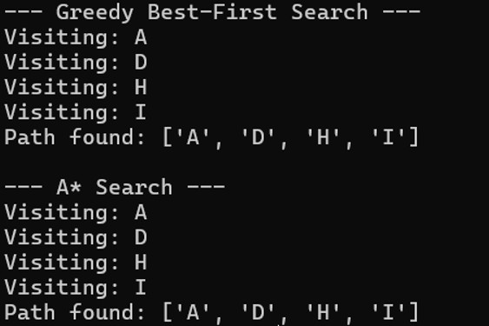

Result:
Thus the above program was implemented and successfully completed.

Exp. No.: 5 Date:
Implementation of a Simple Tic-Tac-Toe Game in Python

Aim:
To design and implement a simple two-player Tic-Tac-Toe game in Python using lists
and functions.

Algorithm:
- Start the program.
- Initialize the game board as a list with 9 positions marked as "-".
- Define a function print_board() and print the board in a 3×3 grid format.
- Define a function take_turn(player):
  - Display the current player's turn.
  - Ask the player to choose a position from 1–9.
  - Validate the input until a correct number is entered.
  - If the position is already filled, ask again.
  - Place the player’s symbol ("X" or "O") in the chosen position.
  - Display the updated board.
- Define a function check_game_over():
  - Check all rows, columns, and diagonals for a win.
  - If a win condition is found → return "win".
  - Else, if no "-" remains on the board → return "tie".
  - Otherwise, return "play".
- Define the main function play_game():
  - Display the initial empty board.
  - Set the current_player as "X".
  - Repeat until the game is over:
    - Call take_turn(current_player).
    - Call check_game_over() to check the game status.

    - If "win", announce winner and end the loop.
    - If "tie", display tie message and end the loop.
    - Otherwise, switch player ("X" ↔ "O") and continue.
- Call play_game() to start the game.
- End the program.

Program:
# Set up the game board board = ["-", "-", "-",
"-", "-", "-",
"-", "-", "-"]
# Print the game board def print_board():
print(board[0] + " | " + board[1] + " | " + board[2]) print(board[3] + " | " + board[4] + " | " + board[5]) print(board[6] + " | " + board[7] + " | " + board[8])
# Handle a player's turn def take_turn(player):
print(player + "'s turn.")
position = input("Choose a position from 1-9: ")
while position not in ["1","2","3","4","5","6","7","8","9"]: position = input("Invalid input. Choose a position from 1-9: ")
position = int(position) - 1 while board[position] != "-":
position = int(input("Position already taken. Choose a different position: ")) - 1 board[position] = player
print_board()
# Check if the game is over def check_game_over():
if (board[0] == board[1] == board[2] != "-") or \

(board[3] == board[4] == board[5] != "-") or \
(board[6] == board[7] == board[8] != "-") or \
(board[0] == board[3] == board[6] != "-") or \
(board[1] == board[4] == board[7] != "-") or \
(board[2] == board[5] == board[8] != "-") or \
(board[0] == board[4] == board[8] != "-") or \
(board[2] == board[4] == board[6] != "-"): return "win"
elif "-" not in board: return "tie"
else:
return "play" # Main game loop def play_game():
print_board() current_player = "X" game_over = False while not game_over:
take_turn(current_player) game_result = check_game_over() if game_result == "win":
print(current_player + " wins!") game_over = True
elif game_result == "tie": print("It's a tie!") game_over = True
else:
current_player = "O" if current_player == "X" else "X" # Start the game
play_game()

Output:
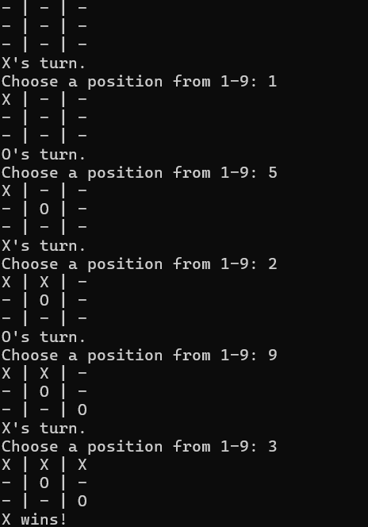

Result:
Thus the above program was implemented and successfully completed.

Exp. No.: 6 Date:

Aim:
Implementing a Basic Propositional Logic Reasoning System

To implement a basic propositional logic reasoning system in Python that can evaluate

logical expressions and determine their truth values based on given facts (truth assignments).

Algorithm:

Manual Evaluation:
  - Start the program.
  - Define propositional variables and assign them truth values (e.g., P = True, Q = False, R
= True).
  - Define functions for logical operations:
    - Implication (→) using (not P) or Q.
    - Biconditional (↔) using (P and Q) or (¬P and ¬Q).
  - Evaluate the following logical expressions:
    - P ∧ Q
    - P ∨ Q
    - ¬Q
    - P → Q
    - P ↔ R
  - Display the results of each expression.
  - End the program.

Using sympy library:
  - Start the program.
  - Import the required library: sympy.
  - Define propositional symbols (e.g., P, Q).
  - Create a knowledge base (KB) using logical expressions (e.g., (P → Q) ∧ P).
  - Define the query (e.g., Q).
  - Check entailment by verifying if KB ∧ ¬Q is unsatisfiable using satisfiable().

  - Display whether KB entails the query.
  - End the program.

Program:

Manual Evaluation:
# Define implication and biconditional functions def implies(p, q):
return (not p) or q def iff(p, q):
return (p and q) or (not p and not q)
# Step 1: Define truth values of propositions propositions = {
'P': True,
'Q': False,
'R': True
}
# Step 2: Evaluate various logical expressions def evaluate_expressions():
print("\n--- Propositional Logic Evaluation ---") # Expression 1: P ∧ Q
result1 = propositions['P'] and propositions['Q'] print("P ∧ Q =", result1)
# Expression 2: P ∨ Q
result2 = propositions['P'] or propositions['Q'] print("P ∨ Q =", result2)
# Expression 3: ¬Q
result3 = not propositions['Q'] print("¬Q =", result3)
# Expression 4: P → Q
result4 = implies(propositions['P'], propositions['Q'])

print("P → Q =", result4) # Expression 5: P ↔ R
result5 = iff(propositions['P'], propositions['R']) print("P ↔ R =", result5)
# Step 3: Call the evaluator evaluate_expressions()

Using sympy library:
from sympy import symbols
from sympy.logic.boolalg import Implies, And, Not, satisfiable # Step 1: Define propositional symbols
P, Q = symbols('P Q')
# Step 2: Knowledge base (KB): (P → Q) ∧ P kb = And(Implies(P, Q), P)
# Step 3: Query: Q query = Q
# Step 4: Check if KB 𝖼 Q
result = not satisfiable(And(kb, Not(query))) # Step 5: Output
print(f"Does KB entail Q? {result}")

Output:
- Manual Evaluation:
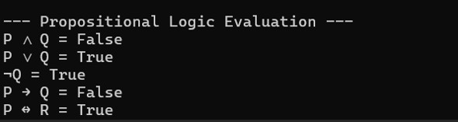

- Using sympy library:

Result:
Thus the above program was implemented and successfully completed.

Exp. No.: 7 Date:

Aim:
Build a Simple Knowledge Base Using First-Order Logic

To build a simple knowledge base using First-Order Logic (FOL), store facts and

rules, and process user queries to derive intelligent conclusions using Python.

Algorithm:
  - Import required modules from the kanren library: Relation, facts, run, var, and conde.
  - Define relations such as student and likes.
  - Insert facts into the knowledge base using facts().
    - Example: Alice and Bob are students; Alice likes Math, Bob likes Science.
  - Define a rule:
    - If a person is a student and likes something, then they are intelligent.
  - Accept user queries such as:
    - “Who is intelligent?”
    - “Is Alice intelligent?”
    - “Is Bob intelligent?”
  - Use the run() function and the defined rules to reason over the knowledge base.
  - Display the results according to the query.

Program:
from kanren import Relation, facts, run, var, conde student = Relation()
likes = Relation()
facts(student, ("alice",), ("bob",))
facts(likes, ("alice", "math"), ("bob", "science")) def is_intelligent(person):
return conde((student(person), likes(person, var())),)

x = var() print("Queries:")
print("1. Who is intelligent?") print("2. Is Alice intelligent?") print("3. Is Bob intelligent?")
choice = input("Enter your query choice (1/2/3): ") if choice == "1":
result = run(0, x, is_intelligent(x)) print("Intelligent people:", list(result))
elif choice == "2":
result = run(0, x, is_intelligent("alice")) if result:
print("Yes, Alice is intelligent.") else:
print("No, Alice is not intelligent.") elif choice == "3":
result = run(0, x, is_intelligent("bob")) if result:
print("Yes, Bob is intelligent.") else:
print("No, Bob is not intelligent.")
else:
print("Invalid query!")

Output:
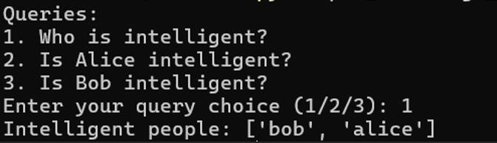

Result:
Thus the above program was implemented and successfully completed.

Exp. No.: 8 Date:
Create a Semantic Network to Represent Relationships Between Objects

Aim:
To construct a semantic network using Python and visualize the relationships (is-a,
has-a) between objects such as Computer, CPU, Monitor, etc.

Algorithm:
- Import required libraries:
  - networkx for graph creation.
  - matplotlib.pyplot for visualization.
- Create a directed graph using nx.DiGraph().
- Add nodes and edges representing relationships between objects.
  - Example: “Computer is-a Machine”, “Computer has-a CPU”.
- Define edge labels such as “is-a” and “has-a”.
- Use spring_layout() to position the graph nodes.
- Draw the graph with nodes, edges, and labels using nx.draw() and nx.draw_networkx_edge_labels().
- Add a title, hide axes, and display the semantic network using plt.show().

Program:
import networkx as nx
import matplotlib.pyplot as plt G = nx.DiGraph() G.add_edges_from([
("Computer", "Machine", {"label": "is-a"}),
("Computer", "CPU", {"label": "has-a"}),
("CPU", "ALU", {"label": "has-a"}),
("CPU", "Control Unit", {"label": "has-a"}),

("Computer", "Monitor", {"label": "has-a"}),
("Monitor", "Output Device", {"label": "is-a"}),
("Computer", "Keyboard", {"label": "has-a"}),
("Keyboard", "Input Device", {"label": "is-a"}),
("Machine", "Thing", {"label": "is-a"})
])
pos = nx.spring_layout(G)
nx.draw(G, pos, with_labels=True, node_color='lightgreen', node_size=2500, font_weight='bold', arrows=True)
nx.draw_networkx_edge_labels(G, pos, edge_labels=nx.get_edge_attributes(G, 'label'), font_color='blue')
plt.axis('off') plt.title("Semantic Network") plt.show()

Output:
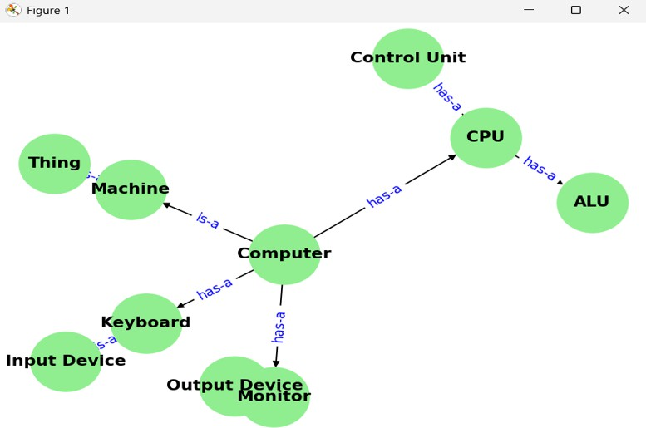

Result:
Thus the above program was implemented and successfully completed.

Exp. No.: 9 Date:
Knowledge-Based Expert System for Medical Diagnosis

Aim:
To build a simple knowledge-based expert system in Python that uses rules for
diagnosis and provides possible diseases based on user symptoms.

Algorithm:
- Define the Knowledge Base:
  - Store medical rules in the format {if: conditions, then: diagnosis}.
  - Each rule contains a set of symptoms that indicate a specific disease.
- Design the Inference Engine:
  - Accept symptoms as input from the user.
  - Convert the symptoms list into a set for easy comparison.
  - Check each rule in the knowledge base.
  - If all symptoms in a rule’s "if" part are present in the user’s symptoms, add the corresponding disease to the matched results.
- User Interface:
  - Prompt the user to enter symptoms separated by commas.
  - Pass the input to the inference engine for processing.
  - Collect the list of possible diagnoses.
- Display Results:
  - If one or more diseases match, print the possible diagnoses.
  - Otherwise, display a message advising the user to consult a doctor.
- End Execution.

Program:
rules = [
{"if": {"fever", "cough", "fatigue"}, "then": "Flu"},
{"if": {"fever", "cough", "shortness of breath"}, "then": "COVID-19"},
{"if": {"headache", "nausea", "sensitivity to light"}, "then": "Migraine"},
{"if": {"sore throat", "runny nose", "sneezing"}, "then": "Common Cold"},
{"if": {"chest pain", "shortness of breath", "dizziness"}, "then": "Heart Attack"},
]
def diagnose(symptoms): matched_diseases = [] symptoms_set = set(symptoms) for rule in rules:
if rule["if"].issubset(symptoms_set): matched_diseases.append(rule["then"])
return matched_diseases def main():
print("\nWelcome to the Medical Expert System")
print("Enter your symptoms separated by commas (e.g., fever, cough):") user_input = input("Symptoms: ").lower()
symptoms = [s.strip() for s in user_input.split(",")] diagnoses = diagnose(symptoms)
if diagnoses:
print("\n⚠ Possible diagnosis(es):") for disease in diagnoses:
print(f"- {disease}")
else:
print("\nNo matching diagnosis found. Please consult a doctor.") if name == " main ":
main()

Output:
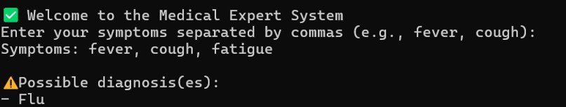

Result:
Thus the above program was implemented and successfully completed.

Exp. No.: 10 Date:

Aim:

Tokenization, Stemming, and Stop-word Removal using NLTK

To implement natural language preprocessing techniques such as tokenization, stop- word removal, and stemming on sample text using Python NLTK library.

Algorithm:
- Import the required libraries from NLTK.
- Download the necessary resources (punkt and stopwords).
- Define a sample text for preprocessing.
- Perform Tokenization using word_tokenize() to split text into words.
- Remove Stop-words and non-alphabetic tokens from the tokenized list.
- Apply Stemming using PorterStemmer to reduce words to their root form.
- Print the original tokens, filtered tokens, and stemmed tokens.

Program:
import nltk
from nltk.tokenize import word_tokenize from nltk.corpus import stopwords
from nltk.stem import PorterStemmer nltk.download('punkt') nltk.download('stopwords')
text = """Perform tokenization, stemming, and stop-word removal on sample text.""" tokens = word_tokenize(text)
stop_words = set(stopwords.words('english'))
filtered_tokens = [word for word in tokens if word.lower() not in stop_words and word.isalpha()]
stemmer = PorterStemmer()

stemmed_tokens = [stemmer.stem(word) for word in filtered_tokens] print("Original Tokens: ", tokens)
print("Filtered Tokens (no stop-words): ", filtered_tokens) print("Stemmed Tokens: ", stemmed_tokens)

Output:
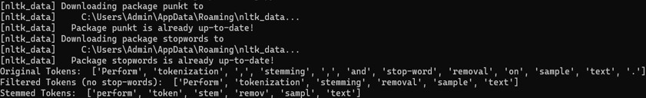

Result:
Thus the above program was implemented and successfully completed.

Exp. No.: 11 Date:

Aim:
Implementation of Speech-to-Text System using Python Speech Recognition Library

To implement a speech-to-text system in Python that captures audio from a

microphone and converts it into text using the SpeechRecognition library.

Algorithm:
- Import the speech_recognition library.
- Create a Recognizer object.
- Access the default microphone as the input source.
- Adjust for ambient noise to improve accuracy.
- Listen to the user’s speech through the microphone.
- Send the recorded audio to Google’s Speech Recognition API.
- If recognized successfully, display the converted text.
- If speech is not clear or API fails, show an error message.

Program:
import speech_recognition as sr def recognize_speech_from_mic():
recognizer = sr.Recognizer() with sr.Microphone() as source:
print("Adjusting for ambient noise... Please wait.") recognizer.adjust_for_ambient_noise(source, duration=1) print("Listening... Speak now.")
audio = recognizer.listen(source) try:
print("Recognizing speech...")

text = recognizer.recognize_google(audio) print("You said:", text)
except sr.UnknownValueError:
print("Sorry, I could not understand the audio.") except sr.RequestError as e:
print(f"Could not request results; {e}") if name == " main ":
recognize_speech_from_mic()

Output:
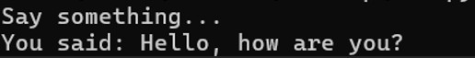

Result:
Thus the above program was implemented and successfully completed.

Exp. No.: 12 Date:
Implementing AI for a Real-world Problem (Predicting Student Performance)

Aim:
To implement an AI-based machine learning model using Decision Tree Classifier to
predict student performance (pass/fail) based on study time, failures, and absences.

Algorithm:
- Import required libraries (pandas, scikit-learn, matplotlib, seaborn).
- Load the student performance dataset.
- Preprocess the data:
  - Create a binary target variable "pass" based on final grade (G3 ≥ 10 → pass).
  - Select relevant features (studytime, failures, absences).
- Split the dataset into training and testing sets.
- Train a Decision Tree Classifier on the training data.
- Predict student performance on the testing data.
- Evaluate the model using accuracy and classification report.
- Visualize feature importance using a bar plot.

Program:
# Install dependencies
# pip install pandas scikit-learn matplotlib seaborn import pandas as pd
from sklearn.model_selection import train_test_split from sklearn.tree import DecisionTreeClassifier
from sklearn.metrics import accuracy_score, classification_report import matplotlib.pyplot as plt

import seaborn as sns # Load dataset
url = 'https://raw.githubusercontent.com/jbrownlee/Datasets/master/student-mat.csv' data = pd.read_csv(url, sep=';')
# Create binary target (pass/fail) data['pass'] = (data['G3'] >= 10).astype(int) # Select features
features = ['studytime', 'failures', 'absences'] X = data[features]
y = data['pass'] # Split data
X_train, X_test, y_train, y_test = train_test_split(X, y, test_size=0.2, random_state=42) # Train Decision Tree model
model = DecisionTreeClassifier() model.fit(X_train, y_train)
# Prediction
y_pred = model.predict(X_test) # Evaluation
print("Accuracy:", accuracy_score(y_test, y_pred)) print(classification_report(y_test, y_pred))
# Feature Importance Plot
importance = model.feature_importances_ sns.barplot(x=features, y=importance) plt.title("Feature Importance")
plt.show()

Output:
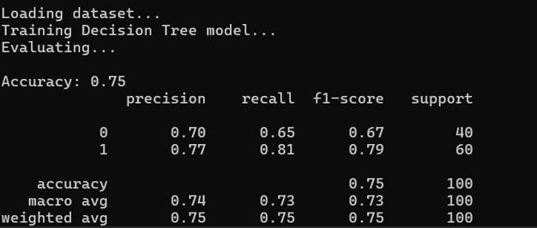

Result:
Thus the above program was implemented and successfully completed.

